Automatic Question Generation from Handwritten Lecture Notes Using TrOCR Text Recognition and T5 Language Processing

¹Rommel John H. Ronduen | ²Jan Adrian C. Manzanero | ³Analyn N. Yumang
School of Electrical, Electronics, and | School of Electrical, Electronics, and | School of Electrical, Electronics, and
Computer Engineering | Computer Engineering | Computer Engineering
Mapua University | Mapua University | Mapua University
Manila, Philippines, 1002 | Manila, Philippines, 1002 | Manila, Philippines, 1002
rjhronduen@mymail.mapua.edu.ph | jacmanzanero@mymail.mapua.edu.ph | anyumang@mapua.edu.ph

Abstract—This research involves the creation and evaluation of a system that allows for text extraction and automatic question generation (AQG) using a T5 and TrOCR pipeline. With the use of a Raspberry Pi 5, web camera, and a touchscreen display, factoid- type questions are created from image captures of single-column handwritten notes that only contain textual information. The T5 large language model (LLM) used was fine-tuned using the Stanford Question Answering Dataset (SQuAD) for facilitating question generation. The system had a word error rate (WER) of 0.40, a ROUGE-1 score of 0.358, and a question validity rate of 68%. This research helps to promote the ease of creation of learning materials in learner education.

Index Terms—Large Language Model, Optical Character Recognition, Automatic Question Generation, Handwritten Lec-ture Notes, Raspberry Pi

- INTRODUCTION

Handwritten lecture notes can be considered as the standard way for capturing and facilitating learning. These lecture notes are learning artifacts that may contain valuable information that can be the basis for other learning elements. One of these learning elements involve review questions. These questions are collected in the form of quizzes and question banks that allow for the enforcement of learning across various fields. Since the introduction of artificial intelligence (AI) to education, there have been several advancements that are attributed to improving the learning experience of students. Automatic question generation (AQG) is one of such advancements. It is achieved using large language models (LLMs) from various inputs that created questions for the assessment or learning enforcement of students.

Despite feasibility in AQG systems, these cannot process handwritten notes due to the lack of integrated optical character recognition (OCR) [1]. AQG is derived from large language models (LLMs) such as T5, BERT, and GPT-3, which have use cases from treebanks [2] and classification of certain texts [3] [4] [5]. Existing AQG frameworks are categorized by their information-processing methods, yet none address handwritten sources [1]. While [6] demonstrated AQG on videos using

BERT for named entity recognition (NER) on transcribed au-dio, textual or handwritten contexts remain unexplored. Other approaches include manual text input with part-of-speech (POS) tagging [7], rule-based methods for programming code [8], and the T5 model fine-tuned on SQuAD for text-based AQG [9]. OCR, defined as image-to-text conversion via convolutional neural networks (CNNs) [10], has been applied to handwritten Baybayin [10], medicinal mushroom classification [11], and expiry date extraction [12]. Through [13], a use case combined CNNs with RNNs for real-time inference, evaluated via confusion matrices [14] [15]. However, Transformer-based OCR (TrOCR) [16], pre-trained on the IAM Handwriting Database, offers superior paragraph-level text recognition over character- focused CNNs [17]. TrOCR’s robustness positions it as a critical enabler for AQG from handwritten lecture notes, addressing the identified gap in media diversity [1].

In bridging the gap for processing handwritten lecture notes for AQG, this research has the general objective of performing AQG from handwritten lecture notes using TrOCR text recognition and T5 language processing. Specifically, this research aims to extract text from handwritten lecture notes using TrOCR and refine such text using the Gemini 1.5 Flash large language model (LLM); utilize a fine-tuned base version of T5 on SQuAD for AQG on indexed keywords from spaCy and Rapid Automatic Keyword Extraction (RAKE) on the refined text; utilize a Raspberry Pi 5 within a constructed enclosure with illumination for facilitating the system processes and experimental setup; and lastly, to evaluate the system using the word error rate (WER) for the OCR, and the Recall-Oriented Understudy for Gisting Evaluation (ROUGE) and the Bilingual Language Understanding Evaluation (BLEU) for the comparison of AQG to the student-generated questions.

This system only considers handwritten lecture notes that are single-column, diagram and equation free, and written in English on plain sheet letter-size paper. It is important to note that this system utilizes the base versions of the T5 and TrOCR models where the former uses SQuAD for the fine-

tuning and Gemini 1.5 Flash for the text correction and context completion of OCR-extracted text as well as the spaCy-Rake keyword extraction for AQG basis. Also, the system operation is confined within the processing capability of the 8-gigabyte model of the Raspberry Pi 5. A different model for OCR or AQG may lead to differing results as well as for the text-enhancing model. Lastly, the usage of alternative hardware may lead to different results.

    - MATERIALS AND METHODS

- Hardware development

  - Block Diagram:
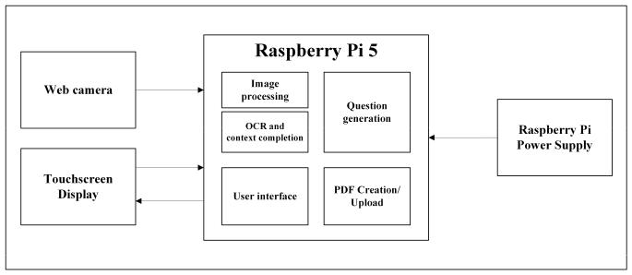

Fig. 1. System block diagram.

Fig. 1 is an illustration for the interconnections of the system. The Raspberry Pi 5 facilitates the system algorithm through the use of the web camera for the capture of hand-written notes and the touchscreen display for the user inputs in dictating the system operation. The power supply for the Raspberry Pi 5 allows for the delivery of power to the acces-sory components and main hardware of the system. A Logitech C922 web camera was used that allowed for autofocus and a 1920 × 1080 pixel capture resolution. Moreover a Waveshare 800 × 480 touchscreen liquid crystal display (LCD) allowed for the display while also providing tactile input.

The services on the system were deployed using Docker as individual representation state transfer (REST) application programming interfaces (APIs). The front end was made using Angular where it acts as the collector of the images of handwritten notes through video feeds and interactive buttons. On the other hand, the back end used Flask that allows for API handling while also supporting the functions needed in facilitating the OCR and AQG processes. Lastly, a portable document format (PDF) file was to be made from the array of question strings that would be uploaded to Google Drive where a consequent download link will be displayed as a quick response (QR) code to the user in the front end.

2) Experimental Setup:

Fig. 2. Constructed prototype and experimental setup.
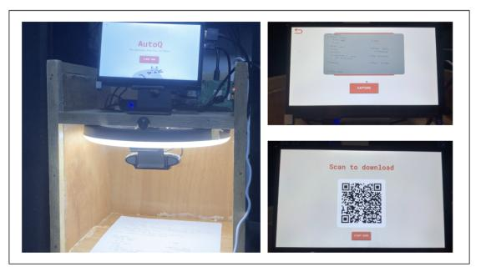

The constructed prototype is shown in Fig. 2. Experimental setup is done where the system demands handwritten notes in the interior of the prototype. An internet connection is required for the experimental setup. The user is then guided by the front-end to capture the handwritten notes. Two halves are captured for the notes where the first half is the top half and the second half is the bottom half. The user is then prompted to confirm the captured notes for the system to proceed with the OCR operation. The system then proceeds with the OCR operation and the AQG operation. The user is then prompted to confirm the generated questions for the system to proceed with the PDF generation. The user is then prompted to download the PDF file for the generated questions.

- Software development

  - Algorithm Pipeline:
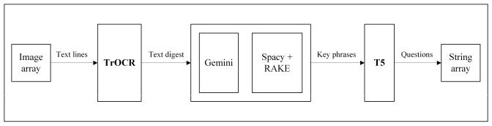

Fig. 3. Algorithm pipeline.

Shown in Fig. 3 is the illustration of the step-by-step flow of information on the system algorithm. An image array in the memory of the system consists of the image captures of the handwritten lecture notes in the form of OpenCV image objects. These images undergo a series of fast means denoising, thresholding, and dilation to detect text lines. These text lines are stored in another array where TrOCR performs batch inferences to attempt extraction from the sources. spaCy and RAKE collects relevant keywords and phrases as a basis for the question generation which is sent to the T5 model for generation of questions. These questions are then stored in an array for portable document file (PDF).
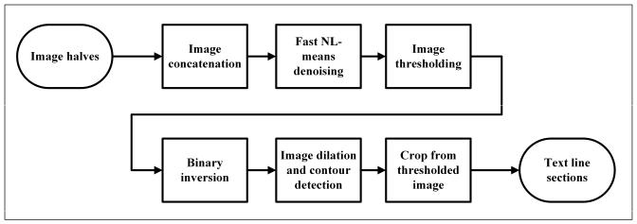

Fig. 4. Text line detection and extraction process.

Revealed in Fig. 4 is the step-by-step procedure for the process of retrieving text lines from a given document. It starts with the receiving of two half scans of a given document. Image concatenation involves the combination of the two to recreate the full document. Fast non-local (NL) means denoising and image thresholding converts the document scan to a more readable document while exposing the shape of the handwritten text. Image binarization and horizontal dilation allows for the reveal of text lines across the document. Finally, individual contours are detected where it is used as a basis for the specific cropping from the thresholded image which allow for a collection of images that contain the individual text lines on the document.
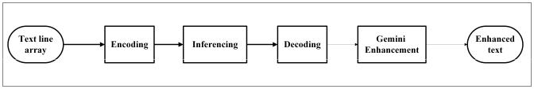

Fig. 5. TrOCR processing.

In Fig. 5, it presents the detailed operation of TrOCR in the system. Coming from the extracted text line images from the process in 4, batch encoding, inferencing, and decoding was done on the array of text lines using the encoder-decoder framework provided by TrOCR. After the extraction procedure, it is prompted to Gemini where error correction is attempted from the OCR extraction.
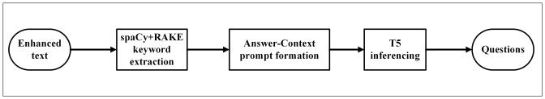
C. Data Collection
Fig. 6. T5 language processing
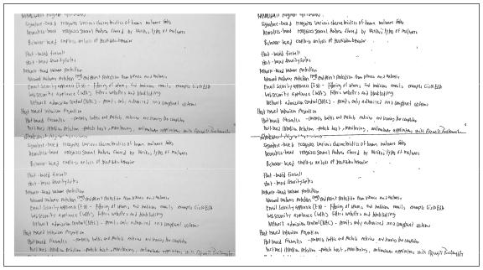

Fig. 7. Sample from the test set. Combined image vs. preprocessed image

Shown in Fig. 7 is a sample from the test set containing 70 handwritten notes collected from undergraduate classes on computer networks and cybersecurity. These notes were written in English, single-column, and diagram-free. A total of 1800 individual text lines were extracted from the notes for the evaluation of the OCR operation through manual transcription and were saved in a comma-separated value (CSV) format for analysis.
Moreover, 135 questions were collected from the students that wrote the notes. The top five most common keywords from the overall extracted text (MAC, ethernet, address, data, and frame) were utilized as the basis for the questions alongside a summary written from the extracted notes that contained such keywords.

Fig. 6 shows the process that uses T5 for AQG. Coming from enhanced text in Fig. 5, the spaCy library and the RAKE algorithm was used to find the relevant keywords and phrases from the text as basis for the questions. Consequently, answer-context pairs are used as prompts that are inputted to the T5 model that generates the questions in an array.

2) Model Training:
The T5 base model was fine-tuned to the SQuADv1.1 dataset for the AQG operation with a learning rate of 3×10⁻⁵ for eight epochs using the Sequence2Sequence trainer. The SQuADv1.1 dataset was loaded using the datasets library where the chosen input features were the context and the question. The output feature was the answer for the given pair of inputs.

D. Testing and Evaluation

TABLE I

TESTING AND EVALUATION TABLE FOR OCR.

 | Student | Model | WER
1
... | ... | ... | ...
70

Average

Shown in Table I is the evaluation of the OCR operation using the word error rate (WER) for the 70 handwritten notes. Testing is done through the collection of the transcribed text versus the inference of the model. The WER is calculated using the formula:


where S is the number of substitutions, D is the number of deletions, I is the number of insertions, and N is the number of words in the reference text.

TABLE II

TESTING AND EVALUATION TABLE FOR AQG.

 | Student | Model | ROUGE | BLEU
1
... | ... | ... | ... | ...
135
 |  |  | Average | Average

Shown in Table II is the evaluation of the AQG operation using the Recall-Oriented Understudy for Gisting Evaluation (ROUGE) and the Bilingual Evaluation Understudy (BLEU). Data collection allowed for the accumulation of 135 questions from students. Using the top five keywords from the hand-written lecture notes, it is compared with the model-generated results using the basis keyword and context. ROUGE and BLEU are computed as follows:

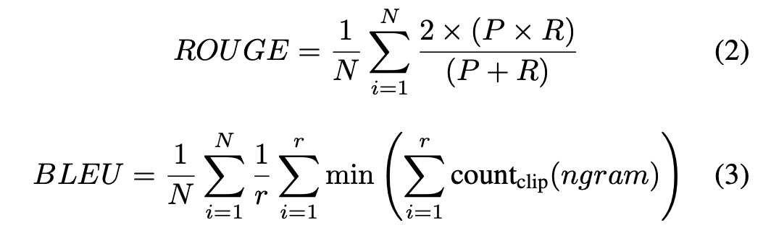

where P is the precision, R is the recall, N is the number of notes, r is the number of reference questions, and count_{clip} is the count of the clipped n-grams.

- RESULTS AND DISCUSSION
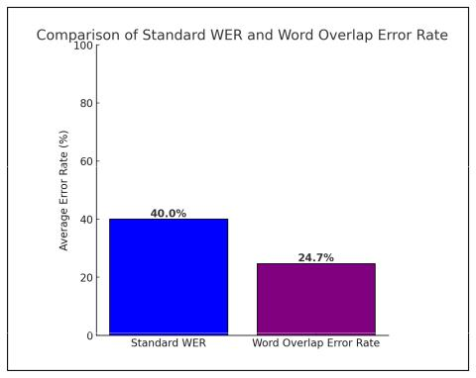

Fig. 8. Computed WER and WOER

In Fig. 8, it was shown that a WER of 0.40 or 40% was realized from the implementation of the TrOCR model with a word overlap error rate (WOER) of 0.247 or 24.7% that measures the completeness of the inference versus the reference. The relatively moderate magnitude of the WER was realized due to the natural misalignment of the text lines from the handwritten notes. Moreover, the lack of use-case specific fine-tuning to TrOCR may have contributed to the WER magnitude. Nevertheless, the the 60% accuracy allowed enough room for Gemini 1.5 Flash to correct and bridge the gaps in the text digest to form valid questions.

Fig. 9. Question Validity Rate Pie Chart
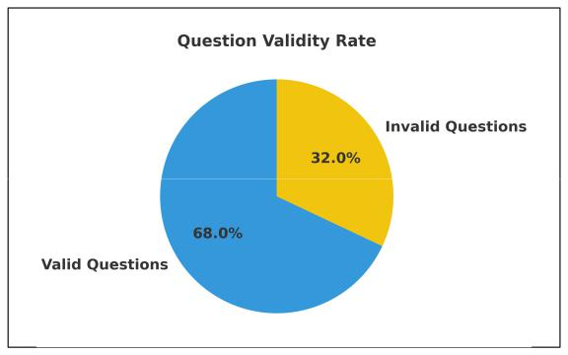
In Fig. 9, it revealed that the generated questions by the system are valid 68% of the time where out of 350 questions, 238 were valid in terms of coherency, grammar, and it’s correlation to the subject matter. The 350 questions were collected as a result of the input of the test set to the system during evaluation. The remaining invalidity was attributed to possibly two aspects. The first is that the T5 model may have too little parameters to generate questions that are more coherent and grammatically correct. The second is that some keywords may have not been corrected by the Gemini 1.5 Flash model which may have led to the propagation of errors in the generated questions.
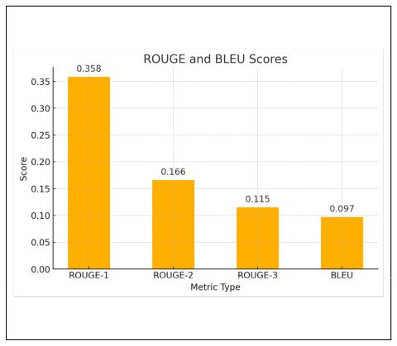

Fig. 10. ROUGE scores and BLEU evaluation

Shown in Fig. 10 is the evaluation of the AQG operation by means of the ROUGE scores and the BLEU scores. It is important to settle first that the questions made by the students tend to be verbatim copies of the basis context. A ROUGE-1 score of 0.358 meant that the system decently captures the relevant keywords in the same way as students do. Moreover, the ROUGE scores 0.166 and 0.115 meant model-based questions differ from the students by syntax because much students verbatimly copy the structure of the context compared to the dynamic outputs of the system. Lastly, the BLEU score of 0.097 meant that the system can pick up context, but not the logical structure of students due to high lexical variability. Ultimately, this means that the questions generated by the system deviate from fixed structure, but not impacting validity (Fig. 9).
IV. CONCLUSION AND RECOMMENDATIONS

It was realized the AQG from handwritten notes through TrOCR was possible, where the Raspberry Pi 5 and the con-structed enclosing was able to cater the process of generating questions decent context capture but unpredictable coherency and structure.

It is recommended that further preprocessing of the image captures to improve the text extraction. Also, the use of larger versions of TrOCR and T5 is recommended alongside the use of a more powerful hardware for the system through processing power and an improved camera for higher image resolutions. It is also recommended that alternative evaluation methods are utilized for this AQG implementation, perhaps in the form of similarity or through semantic analyses.

REFERENCES

- A. Arbaaeen and A. Shah, “Natural language processing based question answering techniques: A survey,” in 7th IEEE International Conference on Engineering Technologies and Applied Sciences, ICETAS 2020. Institute of Electrical and Electronics Engineers Inc., 12 2020.
- D. A. Padilla, A. J. M. Mesina, and E. J. A. Perez, “English treebank of mapua´ university smart interactive voice response system,” in 2020 IEEE 12th International Conference on Humanoid, Nanotechnology, Information Technology, Communication and Control, Environment, and Management (HNICEM). IEEE, 12 2020, pp. 1–6.

- D. A. Padilla, N. K. U. Vitug, and J. B. S. Marquez, “Deep learning approach in gregg shorthand word to english-word conversion,” in 2020 IEEE 5th International Conference on Image, Vision and Computing (ICIVC). IEEE, 7 2020, pp. 204–210.

- J. Mingua, D. Padilla, and E. J. Celino, “Classification of fire re-lated tweets on twitter using bidirectional encoder representations from transformers (bert),” in 2021 IEEE 13th International Conference on Humanoid, Nanotechnology, Information Technology, Communication and Control, Environment, and Management (HNICEM). IEEE, 11 2021, pp. 1–6.

- V. I. D. Rosario, B. D. P. Fernandez, and D. A. Padilla, “Email spam classification using distilbert,” in 2023 IEEE 15th International Confer-ence on Humanoid, Nanotechnology, Information Technology, Communi-cation and Control, Environment, and Management (HNICEM). IEEE, 11 2023, pp. 1–6.

- Y. Y. Ou, S. W. Chuang, W. C. Wang, and J. F. Wang, “Automatic multimedia-based question-answer pairs generation in computer assisted healthy education system,” in 2022 10th International Conference on Orange Technology, ICOT 2022. Institute of Electrical and Electronics Engineers Inc., 2022.

- M. Moron, J. Scocozza, L. Chiruzzo, and A. Rosa, “A tool for automatic question generation for teaching english to beginner students,” in Pro-ceedings - International Conference of the Chilean Computer Science Society, SCCC, vol. 2021-November. IEEE Computer Society, 2021.

- H. Gaur, D. K. Tayal, and A. Jain, “Viqg: Web tool for automatic ques-tion generation from code for viva preparation,” in Proceedings of 2023 26th Conference of the Oriental COCOSDA International Committee for the Co-Ordination and Standardization of Speech Databases and Assessment Techniques, O-COCOSDA 2023. Institute of Electrical and Electronics Engineers Inc., 2023.

- D. C. Tsai, A. Y. Huang, O. H. Lu, and S. J. Yang, “Automatic question generation for repeated testing to improve student learning outcome,” in Proceedings - IEEE 21st International Conference on Advanced Learning Technologies, ICALT 2021. Institute of Electrical and Electronics Engineers Inc., 7 2021, pp. 339–341.

- A. M. P. Ligsay, J. B. Rivera, and J. F. Villaverde, “Optical character recognition of baybayin writing system using yolov3 algorithm,” in 2022 IEEE International Conference on Artificial Intelligence in Engineering and Technology (IICAIET). IEEE, 9 2022, pp. 1–5.

- M. J. Y. Sutayco and M. V. C. Caya, “A comparative study of mobilenetv2 and vgg-16 convolutional neural network architectures for identification of medicinal mushrooms.” Institute of Electrical and Electronics Engineers (IEEE), 7 2024, pp. 1–6.

- C. O. Manlises, D. A. Padilla, J. B. Santos, and P. A. Adviento, “Expiration identification of canned goods using convolutional neural network,” in 2024 7th International Conference on Information and Computer Technologies (ICICT). IEEE, 3 2024, pp. 173–177.
- A. D. R. Calimag, D. A. Padilla, and C. O. Manlises, “Checkout system with object detection using nvidia jetson nano and raspberry pi,” in 2023 IEEE 5th Eurasia Conference on IOT, Communication and Engineering (ECICE). IEEE, 10 2023, pp. 168–171.

- C. Ishikawa, J. A. U. Marasigan, and M. V. C. Caya, “Cloud-based signature validation using cnn inception-resnet architecture,” in 2020 IEEE 12th International Conference on Humanoid, Nanotechnology, Information Technology, Communication and Control, Environment, and Management (HNICEM). IEEE, 12 2020, pp. 1–6.

- J. F. Villaverde, M. D. Ferrer, J. A. T. Macabeo, and J. T. Masilungan-Manuel, “Classification of cotton fabric, pineapple fabric and cotton pineapple blend fabric with vgg16 using keras,” in 2023 IEEE 15th International Conference on Humanoid, Nanotechnology, Information Technology, Communication and Control, Environment, and Manage-ment (HNICEM). IEEE, 11 2023, pp. 1–6.

- M. Li, T. Lv, J. Chen, L. Cui, Y. Lu, D. Florencio, C. Zhang, Z. Li, and F. Wei, “Trocr: Transformer-based optical character recognition with pre-trained models,” 9 2021.

- A. Mortadi, A. Mohamed, A. Talima, A. Alkhattip, A. Ibrahim, A. Osman, and Y. Hifny, “Alnasikh: An arabic ocr system based on transformers,” in 2023 International Mobile, Intelligent, and Ubiquitous Computing Conference (MIUCC). IEEE, 9 2023, pp. 74–81.

